Montessori Reading Program LINKS & RESOURCES
Questions? Email Audrey Frazier: audrey@aastorage.com
Teaching the Sounds
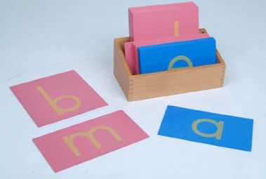
- Sandpaper Letters or
- Tactile Letters (salt, felt, glitter glue, puffy paint, etc.)
TO PURCHASE SANDPAPER LETTERS:
http://www.montessorioutlet.com/cgi-bin/category.cgi?&category=5104 Traditional Sandpaper letters from Montessori Outlet $24.95
http://www.montessorioutlet.com/cgi-bin/item/510400040/5104/Montessori-Outlet-Box-for-the-Sandpaper-Letters Box for Traditional Sandpaper letters from Montessori Outlet, $8.95
TO MAKE WITH 3D MATERIAL OF YOUR CHOICE
https://docs.google.com/viewer?a=v&pid=explorer&chrome=true&srcid=0B-Jp2xvcHjp4ODU2ZjA1MjUtYjdjZi00MGE5LTg1ZDctNjk3MjFlMTAzNDg4&hl=en_US Letter Wall Charts. Colored lowercase alphabet cards, ready to print on white cardstock to make homemade Sandpaper Letters.

http://www.montessorimaterials.org/Language/printlower.pdf Black lower case alphabet cards ready to print on colored cardstock for homemade Sandpaper Letters. (Pink/red paper for consonants, light blue paper for vowels)
http://montessorimom.com/sandpaper-letters/ Solid color background lowercase alphabet cards ready to print on white cardstock for homemade sandpaper letters.

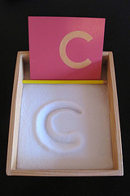
- Salt Tray
An extension of the Sandpaper Letters activity. Flat container with salt for tracing the letters.


- Tracing Letters
An extension of the Sandpaper Letters activity. Child traces inside the bubble letter 6 times - one with each of 6 rainbow colored pencils (red, orange, yellow, green, blue, purple) PDF document is uploaded and posted on www.aastorage.com/school/notes.htm

- Initial Sound Cards

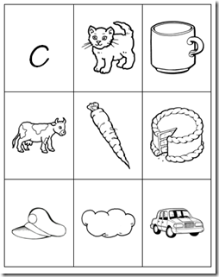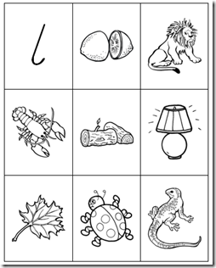
http://unitedteaching.com/blog/?cat=17&paged=2
PDF file. Print vowel cards on light blue paper and consonants on pink paper. Put in sheet protectors in 3 ring binder. $5.95 for PDF.

Moveable Alphabet
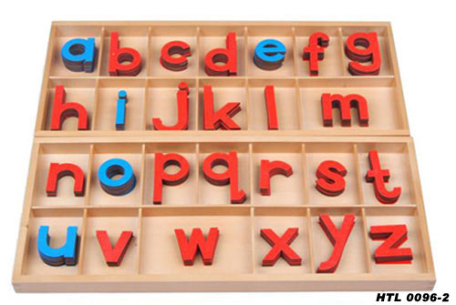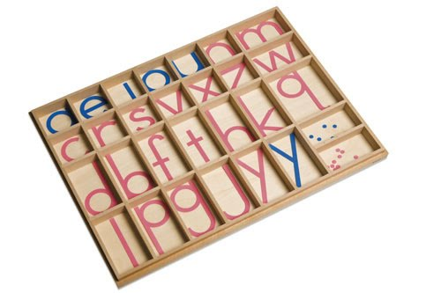

http://www.montessorioutlet.com/cgi-bin/item/510400090/5104/Montessori-Outlet-Small-Movable-Alphabet-%28Print%2C-Mix-Blue-%26-Red%29 Traditional Moveable Alphabet from Montessori Outlet, $16.95
http://www.montessorioutlet.com/cgi-bin/item/510400350/5104/Montessori-Outlet-Small-Movable-Alphabet-Box-%28Lower-Case-Letters%29 Box for traditional Moveable Alphabet from Montessori Outlet, $16.95

http://www.montessorimaterials.org/Language/MovableAlphabet.pdf
Free Printable Moveable Alphabet Cards to print on cardstock and laminate. You would still need to find a tackle box in which to organize the cards. I bought one at Walmart for around $8.

Metal Insets for Design
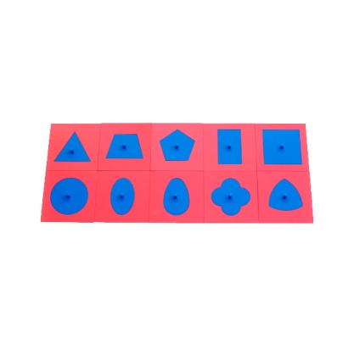
http://www.montessorioutlet.com/cgi-bin/item/510400400/5104/Montessori-Outlet-Metal-Insets Metal Insets (Insets for Design) from Montessori Outlet,
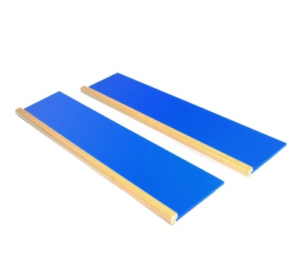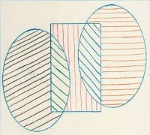
http://www.montessorioutlet.com/cgi-bin/item/510400410/5104/Montessori-Outlet-Metal-Insets-Stands
Metal Inset stands from Montessori Outlet, $27.95

http://www.practical-homeschooling.org/2008/09/template-metal-insets/ Template for making homemade Metal Insets of Design using a rigid material of your choice.

Pink and Blue Reading Series
OBJECTS:
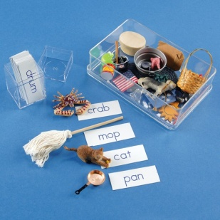 http://montessorimom.com/phonetic-word-list/
Lists of phonetic words. Helpful if you want to make your own reading materials. Also provides ideas for objects to collect for Pink and Blue Reading steps 1 and 3.

http://www.montessoriservices.com/language/early-reading-activities/phonetic-object-box-1 Phonetic object box from Montessori Services. 30 assorted objects and word cards to use with Pink and Blue Reading steps 1 and 3. $27.95

http://montessori-n-such.com/detail.aspx?ID=1352 Objects from Montessori-n-Such
L2400K Two & Three Letter Short Vowel Object Set A - collection of 20 attractive objects (for Pink Reading). $13.99
L2401K Four Letter Short Vowel Object Set A - collection of 15 appealing objects (for Blue Reading). $13.99

http://www.gluesky.com/2010/05/making-montessori-objects-for-reading/ Make your own objects out of modeling clay. Adorable, but a lot of work!
I personally have never bought a prepackaged object set, but think it would not be a bad idea. I have collected objects over time, a little here and a little there. I am always on the lookout for new phonetic objects! Barbi accessories work well, as do Playmobil pieces. Ebay sometimes sells bags of miscellaneous Barbi pieces. Dollar stores, thrift store toy bins, your own children’s toy box, and the family office junk drawer are all good places to start.
Examples of objects for Pink Reading:
bud, a bud from a fake flower
pot, a mini black cauldron pot from a Halloween party favor
web, a mini plastic spider web from a Halloween party favor
nut, a real whole walnut
bed, a Fisher Price little yellow plastic bed
egg, a fake egg (Dollar Tree has lots of cute little eggs right now)
hat, I stole the hat off of my kids’s Woody action figure from Toy Story.
peg, just a wooded peg from an old coat hook board
box, a cute little box wrapped with wrapping paper
red, a square of red felt
fan, a mini fan I made with a rectangle of scrapbook paper, wrapped at the bottom with string
cap, a fire fighters cap and also a baseball cap, both from my kids’s toy box
bag, a Barbi bag
log, a mini Lincoln log
pin, a large cute pink diaper pin
pan, a Barbi pan
top, a cute toy top
ram, a toy animal
tug, a tugboat
tub, a mini metal tub

Pronunciation guide: no vowel sound after consonants (“d” not “duh”)
Short vowel sounds, hard consonant sounds, every letter of the word must be represented with an individual sound.

PDF PAPER FILES

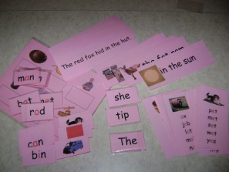
http://thehelpfulgarden.blogspot.com/search/label/Language%20Arts
Pink and Blue Reading series. Free. This website has step-by-step picture guides along with the PDFs.

http://www.practical-homeschooling.org/2009/10/montessori-pink-level-available-for-free/
Pink Reading Series. Free

Green Reading Series, Phonograms
http://montessorimom.com/phonogram-words/
Lists of words with phonograms
***NOTE: ALL PHONGRAM LINKS ARE TO PDF’S PURCHASABLE THROUGH MONTESSORI PRINT SHOP. IN A MONTH OR SO, www.thehelpfulgarden.blogspot.com WILL HAVE POSTED A FULL GREEN READING SERIES FOR FREE.

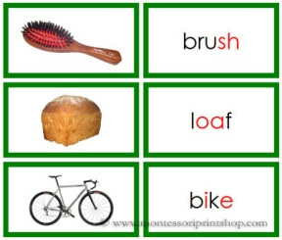 http://www.shop.montessoriprintshop.com/Green-Phonogram-Word-and-Picture-Cards-Set-1-Real-Pictures-LF-3ap.htm Green Phonogram Word and Picture Cards - Set 1-Real Pictures, from Montessori Print Shop. Includes 12 sets of phonograms: sh, ee, oa, or, ai, ow, ch, i-e, ea, oo, a-e, er. PDF $2.49

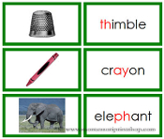 http://www.shop.montessoriprintshop.com/Green-Phonogram-Word-and-Picture-Cards-Set-2-Real-Pictures-LF-3bp.htm Green Phonogram Word and Picture Cards - Set 2 - Real Pictures, from Montessori Print Shop. Includes 12 sets of phonograms: o, y, e, ow, ar, qu, th, ay, o-e, ph, aw, o. PDF $3.49

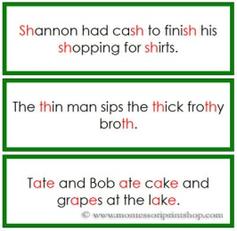 http://www.shop.montessoriprintshop.com/Green-Phonogram-Sentence-Cards-LF-3c.htm

Green Phonogram Sentence Cards PDF $2.99

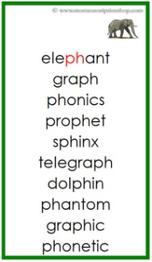 http://www.shop.montessoriprintshop.com/Green-Phonogram-Cards-Set-1-LF-15a.htm Green Phonogram Cards - Set 1. 44 Word Lists with picture on top. $2.79

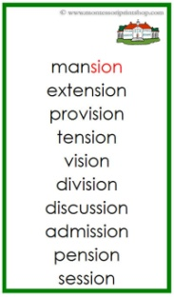 http://www.shop.montessoriprintshop.com/Green-Phonogram-Cards-Set-2-LF-15b.htm

33 Word Lists with Picture on top. $2.49

